Volume Group with ORM Stack

Contents

1. Introduction 3
2. Workflow diagram to deploy the stack 3
3. Create Stack 4
4. Upload the Artifacts 5
5. Plan the Job 7
6. Apply the Job 7
7. Verify in the Console 8
8. Destroy the stack 8

Introduction

The Oracle Cloud Infrastructure Block Volume service provides you with the capability to group together multiple volumes in a volume group. A volume group can include both types of volumes, boot volumes, which are the system disks for your compute instances, and block volumes for your data storage. Customer can use volume groups to create volume group backups and clones that are point-in-time and crash-consistent.
This simplifies the process to create time-consistent backups of running enterprise applications that span multiple storage volumes across multiple instances. Customer can then restore an entire group of volumes from a volume group backup.
Similarly, this can also clone an entire volume group in a time-consistent and crash-consistent manner. A deep disk-to-disk and fully isolated clone of a volume group, with all the volumes associated in it, becomes available for use within a matter of seconds. This speeds up the process of creating new environments for development, quality assurance, user acceptance testing, and troubleshooting.

Workflow diagram to deploy the stack
Below diagram shows how the Terraform Artifact are applied in the OCI. While creating a ORM stack, using terraform deliverables Init, Plan and Apply is the flow to provision the resource in the OCI. We can have the deliverables in any of below.
- GitLab/GitHub Repo
- Bitbucket
- Can be in folder/.zip in the local disk
- Object Storage Bucket
- Can be in compartment
- Oracle provided Template


Create Stack

Go to OCI Console Developer Services Resource Manager Stacks select the compartment Create Stack

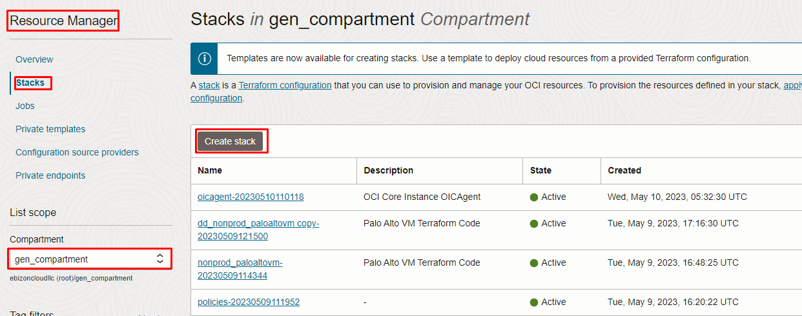

Upload the Artifacts

My Configuration Folder Browse

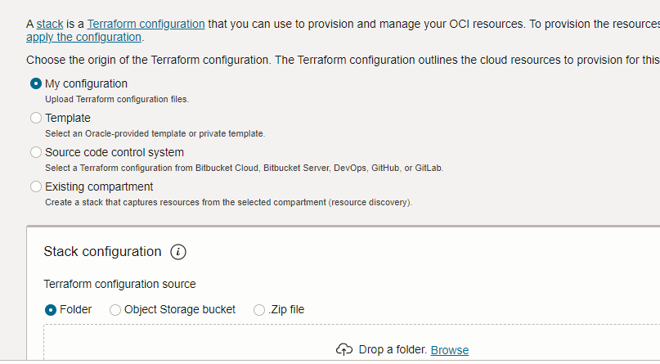

Review the values in the Configure Variables page and click Next

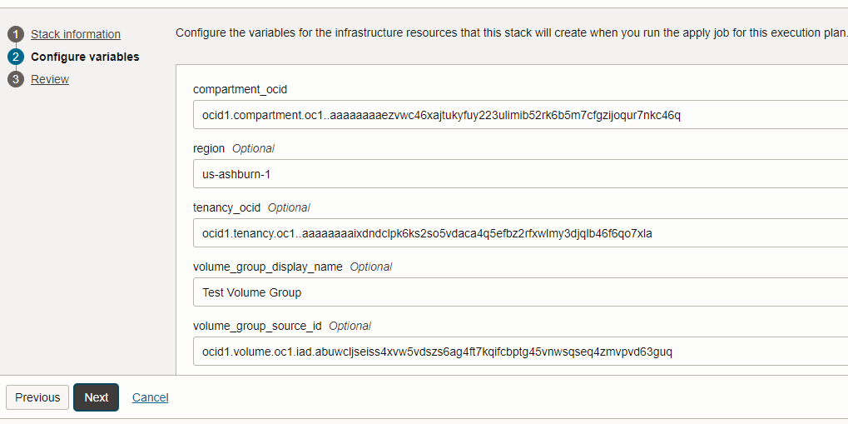

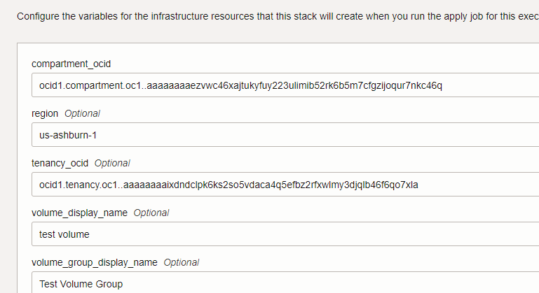
Review

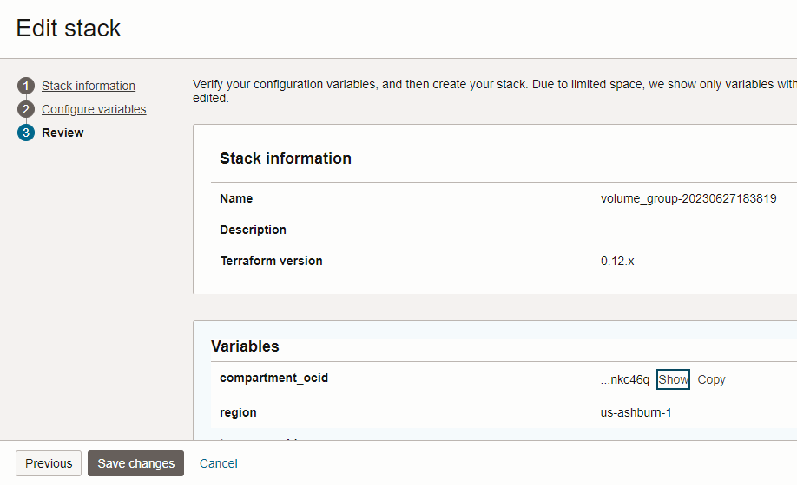
Click save changes and click create

Plan the Job

Click the “Plan”

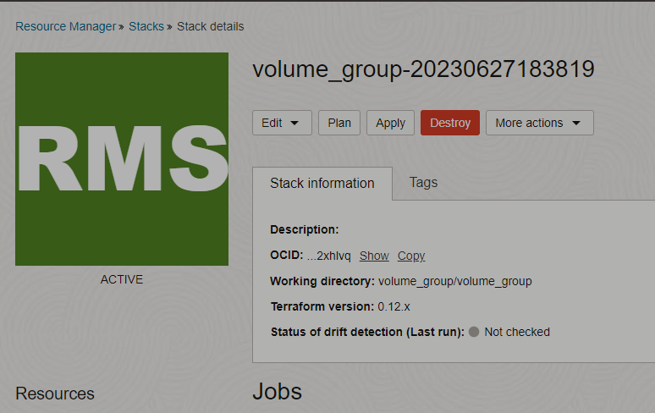

Verify the Plan is successful.

Apply the Job
Once the “plan” is success, now click “Apply”
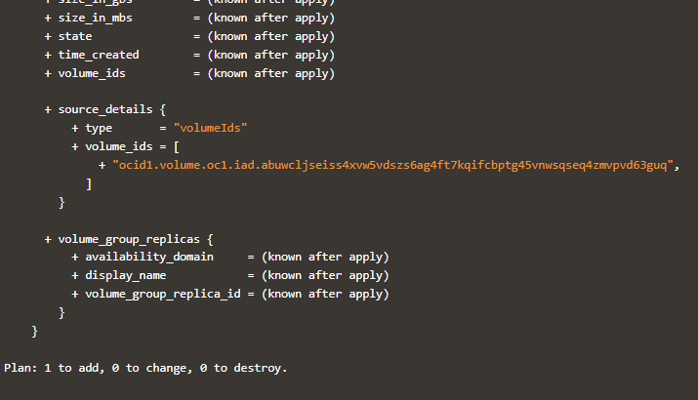

Verify the Apply is successful.
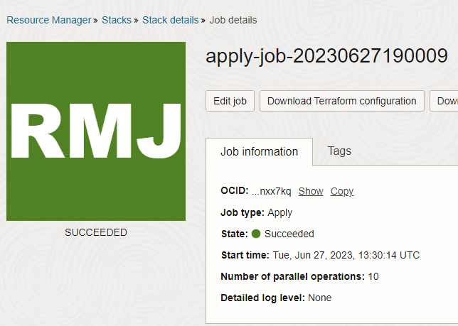

Verify in the Console

Go to OCI Console Storage Volume Group
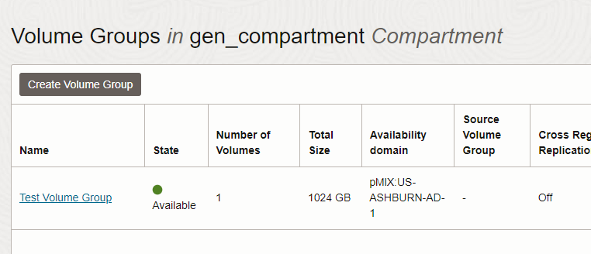

Destroy the stack
Create a destroy job in Resource Manager to release resources associated with a stack and clean up the tenancy. Once destroyed data cannot be recovered from resources

# END #

